Computer Graphics Zooming

Zooming is a transformation often provided with an imaginary software. The transformation effectively scales down or blows up a pixel map or a portion of it with the instructions from the user. Such scaling is commonly implemented at the pixel level rather than at the coordinates level. A video display or an image is necessarily a pixel map, i.e., a collection of pixels which are the smallest addressable elements of a picture. The process of zooming replicates pixels along successive scan lines.

**Example:** for a zoom factor of two

Each pixel value is used four times twice on each of the two successive scan lines.

Figure shows the effect of zooming by a factor of 2.

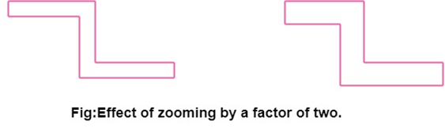

Such integration of pixels sometimes involves replication using a set of ordered patterns, commonly known as Dithering.

The two most common dither types are:

* Ordered dither.
* Random dither.

There are widely used, especially when the grey levels (share of brightness) are synthetically generated.

